Practical No: 1 Date:

Aim : Design and develop location based messaging app.

Source Code:

activity_main.xml

<?xml version="1.0" encoding="utf-8"?>

<RelativeLayout xmlns:android="http://schemas.android.com/apk/res/android" xmlns:tools="http://schemas.android.com/tools" android:layout_width="match_parent" android:layout_height="match_parent" android:paddingBottom="@dimen/activity_vertical_margin" android:paddingLeft="@dimen/activity_horizontal_margin" android:paddingRight="@dimen/activity_horizontal_margin" android:paddingTop="@dimen/activity_vertical_margin" tools:context="com.example.dell.lbmsg.MainActivity">

<TextView android:layout_width="wrap_content" android:layout_height="wrap_content"

android:textAppearance="?android:attr/textAppearanceLarge" android:text="Large Text"

android:id="@+id/textView" android:layout_alignParentLeft="true" android:layout_alignParentStart="true" />

<TextView android:layout_width="wrap_content" android:layout_height="wrap_content"

android:textAppearance="?android:attr/textAppearanceLarge" android:text="Large Text"

android:id="@+id/textView3" android:layout_below="@+id/textView" android:layout_alignParentLeft="true" android:layout_alignParentStart="true" android:layout_marginTop="96dp" />

<Button android:layout_width="wrap_content" android:layout_height="wrap_content" android:text="Get Longitude and Latitude" android:id="@+id/button" android:layout_centerVertical="true" android:layout_alignParentLeft="true" android:layout_alignParentStart="true" />

Ubiquitous Computing

Msc CS Sem 3 Roll No - 20

<TextView android:layout_width="wrap_content" android:layout_height="wrap_content"

android:textAppearance="?android:attr/textAppearanceLarge" android:text="Large Text"

android:id="@+id/textView2" android:layout_alignParentBottom="true" android:layout_alignRight="@+id/button" android:layout_alignEnd="@+id/button" />

</RelativeLayout>

MainActivity.java

package com.example.dell.lbmsg; import android.Manifest;
import android.content.Context;

import android.content.pm.PackageManager; import android.location.Location;

import android.location.LocationListener; import android.location.LocationManager; import android.net.Uri;
import android.os.Bundle;

import android.support.v7.app.AppCompatActivity; import android.support.v4.app.ActivityCompat; import android.util.Log;

import android.view.View; import android.widget.Button; import android.widget.TextView;

import com.google.android.gms.appindexing.Action; import com.google.android.gms.appindexing.AppIndex;

import com.google.android.gms.common.api.GoogleApiClient;

public class MainActivity extends AppCompatActivity implements LocationListener {
TextView t1, t2, t3;

Button b1;

protected LocationManager locationManager; protected LocationListener locationListener; double lat, longg;

private GoogleApiClient client; @Override

protected void onCreate(Bundle savedInstanceState) { super.onCreate(savedInstanceState); setContentView(R.layout.activity_main);

t1 = (TextView) findViewById(R.id.textView);
t2 = (TextView) findViewById(R.id.textView3);
t3 = (TextView) findViewById(R.id.textView2);

b1 = (Button) findViewById(R.id.button);

b1.setOnClickListener(new View.OnClickListener() {
@Override

public void onClick(View view) { t1.setText("Latitude = " + lat); t2.setText("Longitude = " + longg);

Ubiquitous Computing

if (lat<38 &&lat>36 &&longg<122 &&longg>118) { t3.setText("In-Side The Area");

} else {
t3.setText("Out-Side The Area");
}
}
});

locationManager= (LocationManager) getSystemService(Context.LOCATION_SERVICE);

if (ActivityCompat.checkSelfPermission(this, Manifest.permission.ACCESS_FINE_LOCATION) != PackageManager.PERMISSION_GRANTED&&ActivityCompat.checkSelfPermission(this, Manifest.permission.ACCESS_COARSE_LOCATION) != PackageManager.PERMISSION_GRANTED) {

return;
}
locationManager.requestLocationUpdates(LocationManager.GPS_PROVIDER, 0, 0,
this);

client = new GoogleApiClient.Builder(this).addApi(AppIndex.API).build();
}

@Override
public void onLocationChanged(Location location) {

// txtLat = (TextView) findViewById(R.id.textview1); lat= location.getLatitude();

longg= location.getLongitude(); Log.d("" + lat, "" + lat); Log.d("" + longg, "" + longg);

if (lat== 38 &&longg== 118) { t3.setText("You Are at Perfect Place !!!!");

} else {
t3.setText("You are not at Perfect Place !!!!");

}

@Override

public void onStatusChanged(String provider, int status, Bundle extras) { Log.d("Latitude", "status");

}

@Override

public void onProviderDisabled(String provider) { Log.d("Latitude", "disable");

}

@Override

public void onProviderEnabled(String provider) { Log.d("Latitude", "enable");

}

@Override

public void onStart() { super.onStart();

- ATTENTION: This was auto-generated to implement the App Indexing API.

  - See https://g.co/AppIndexing/AndroidStudio for more information. client.connect();

Action viewAction = Action.newAction( Action.TYPE_VIEW, // TODO: choose an action type.
"Main Page", // TODO: Define a title for the content shown.
    - TODO: If you have web page content that matches this app activity's content,
    - make sure this auto-generated web page URL is correct.
    - Otherwise, set the URL to null.
Uri.parse("http://host/path"),
// TODO: Make sure this auto-generated app URL is correct.

Uri.parse("android-app://com.example.dell.lbmsg/http/host/path")
);
AppIndex.AppIndexApi.start(client, viewAction);
}

@Override
public void onStop()
{
super.onStop();

- ATTENTION: This was auto-generated to implement the App Indexing API.
  - See https://g.co/AppIndexing/AndroidStudio for more information.

Action viewAction = Action.newAction(
Action.TYPE_VIEW, // TODO: choose an action type.
"Main Page", // TODO: Define a title for the content shown.
- TODO: If you have web page content that matches this app activity's content,
- make sure this auto-generated web page URL is correct.
- Otherwise, set the URL to null.
Uri.parse("http://host/path"),
// TODO: Make sure this auto-generated app URL is correct.
Uri.parse("android-app://com.example.dell.lbmsg/http/host/path")
);

AppIndex.AppIndexApi.end(client, viewAction); client.disconnect();}
}

AndroidManifest.xml

<?xml version="1.0" encoding="utf-8"?>

<manifest xmlns:android="http://schemas.android.com/apk/res/android" package="com.example.dell.lbmsg">
<uses-permission android:name="android.permission.ACCESS_FINE_LOCATION" />

<uses-permission android:name="android.permission.INTERNET" /> <application

android:allowBackup="true" android:icon="@mipmap/ic_launcher" android:label="@string/app_name" android:supportsRtl="true" android:theme="@style/AppTheme"> <activity android:name=".MainActivity">
<intent-filter>

<action android:name="android.intent.action.MAIN" />

<category android:name="android.intent.category.LAUNCHER" /> </intent-filter>

</activity> <meta-data

android:name="com.google.android.gms.version" android:value="@integer/google_play_services_version" />

</application> </manifest>
Output:
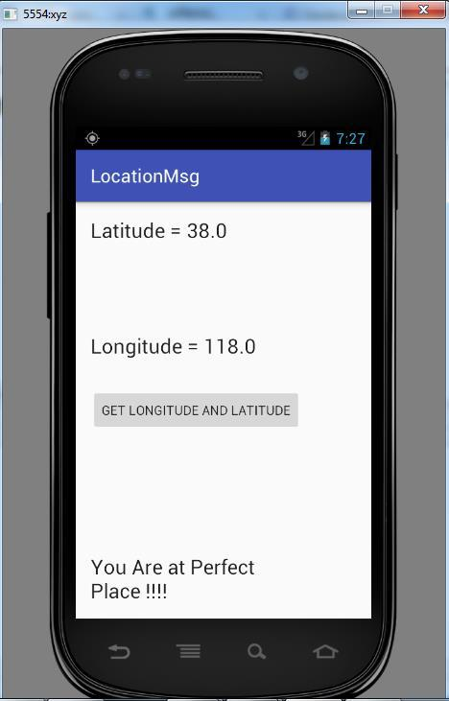

Practical No : 2 Date:

Aim : Design and develop chat messaging app which is a location-based. Source Code :
activity_main.xml

<?xml version="1.0" encoding="utf-8"?>

<RelativeLayout xmlns:android="http://schemas.android.com/apk/res/android" xmlns:tools="http://schemas.android.com/tools" android:layout_width="match_parent" android:layout_height="match_parent" android:paddingBottom="@dimen/activity_vertical_margin" android:paddingLeft="@dimen/activity_horizontal_margin" android:paddingRight="@dimen/activity_horizontal_margin" android:paddingTop="@dimen/activity_vertical_margin" tools:context="com.example.dell.location_based.MainActivity">

<TextView android:layout_width="wrap_content" android:layout_height="wrap_content"

android:textAppearance="?android:attr/textAppearanceLarge" android:text="Large Text"

android:id="@+id/textView" android:layout_alignParentLeft="true" android:layout_alignParentStart="true" />

<TextView android:layout_width="wrap_content" android:layout_height="wrap_content"

android:textAppearance="?android:attr/textAppearanceLarge" android:text="Large Text"

android:id="@+id/textView3" android:layout_below="@+id/textView" android:layout_alignParentLeft="true" android:layout_alignParentStart="true" android:layout_marginTop="96dp" />

<Button android:layout_width="wrap_content" android:layout_height="wrap_content" android:text="Get Longitude and Latitude" android:id="@+id/button" android:layout_centerVertical="true" android:layout_alignParentLeft="true" android:layout_alignParentStart="true" />

<TextView android:layout_width="wrap_content" android:layout_height="wrap_content"

android:textAppearance="?android:attr/textAppearanceLarge" android:text="Large Text"

android:id="@+id/textView2" android:layout_alignParentBottom="true" android:layout_alignRight="@+id/button" android:layout_alignEnd="@+id/button" />

</RelativeLayout>

Ubiquitous Computing

MainActivity.java

package com.example.dell.location_based;

import android.Manifest; import android.content.Context;

import android.content.pm.PackageManager; import android.location.Location;

import android.location.LocationListener; import android.location.LocationManager; import android.support.v4.app.ActivityCompat; import android.util.Log;

import android.view.View; import android.widget.Button; import android.widget.TextView;

import android.support.v7.app.AppCompatActivity; import android.os.Bundle;

public class MainActivity extends AppCompatActivity implements LocationListener { TextView t1, t2, t3;

Button b1;

protected LocationManager locationManager; protected LocationListener locationListener; double lat, longg;

@Override

protected void onCreate(Bundle savedInstanceState) { super.onCreate(savedInstanceState);

setContentView(R.layout.activity_main); // setContentView(R.layout.activity_main);

t1 = (TextView) findViewById(R.id.textView);
t2 = (TextView) findViewById(R.id.textView3);
t3 = (TextView) findViewById(R.id.textView2);

b1 = (Button) findViewById(R.id.button);

b1.setOnClickListener(new View.OnClickListener() { @Override

public void onClick(View view) { t1.setText("Latitude = " + lat); t2.setText("Longitude = "+ longg);

if(lat<38 &&lat>36 &&longg<122 &&longg>118)
{
t3.setText("In-Side The Area");
}
else {

t3.setText("Out-Side The Area");
} }
});

locationManager= (LocationManager) getSystemService(Context.LOCATION_SERVICE);

if (ActivityCompat.checkSelfPermission(this, Manifest.permission.ACCESS_FINE_LOCATION) != PackageManager.PERMISSION_GRANTED&&ActivityCompat.checkSelfPermission(this, Manifest.permission.ACCESS_COARSE_LOCATION) != PackageManager.PERMISSION_GRANTED) {

return;
}

locationManager.requestLocationUpdates(LocationManager.GPS_PROVIDER, 0, 0, this);

}
@Override

public void onLocationChanged(Location location) { lat=location.getLatitude();

longg= location.getLongitude(); Log.d(""+lat,""+lat); Log.d(""+longg,""+longg);

if(lat<38 &&lat>36 &&longg<122 &&longg>118) { t3.setText("In-Side The Area");

}
else {
t3.setText("Out-Side The Area");
}
}
@Override

public void onProviderDisabled(String provider) { Log.d("Latitude","disable");

}

@Override

public void onProviderEnabled(String provider) { Log.d("Latitude","enable");

}
@Override

public void onStatusChanged(String provider, int status, Bundle extras) { Log.d("Latitude","status");

}
}

AndroidManifest.xml

<?xml version="1.0" encoding="utf-8"?>

<manifest xmlns:android="http://schemas.android.com/apk/res/android" package="com.example.dell.location_based">

<application android:allowBackup="true" android:icon="@mipmap/ic_launcher" android:label="@string/app_name" android:supportsRtl="true" android:theme="@style/AppTheme">

<activity android:name=".MainActivity"> <intent-filter>
<action android:name="android.intent.action.MAIN" />

<category android:name="android.intent.category.LAUNCHER" /> </intent-filter>

</activity> </application>

<uses-permission android:name="android.permission.ACCESS_FINE_LOCATION" /> <uses-permission android:name="android.permission.INTERNET" />

</manifest>

Output :
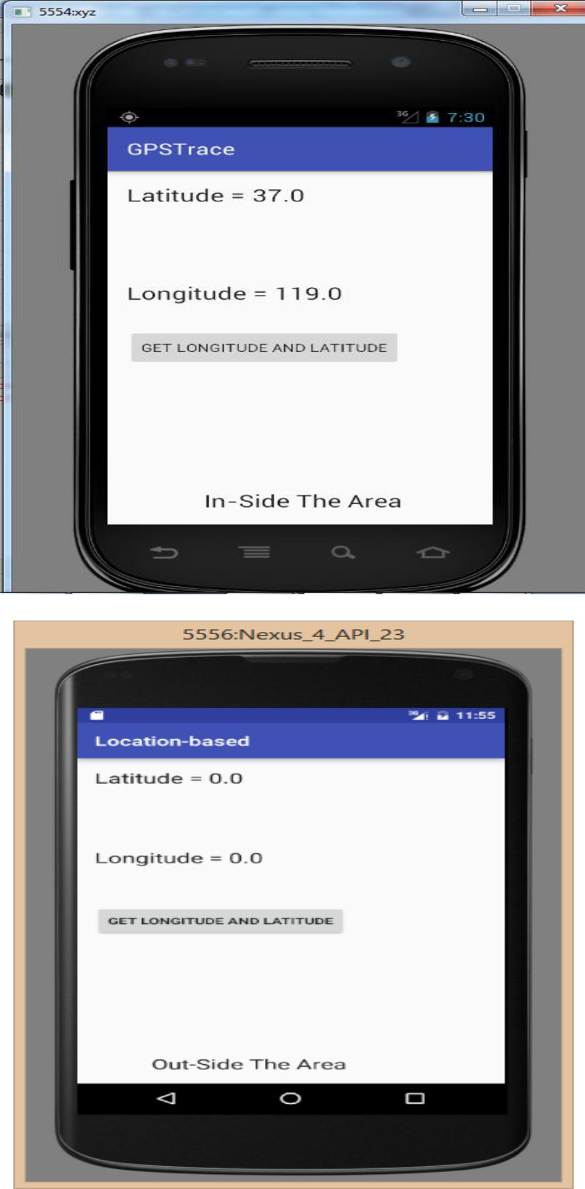

Practical No : 7 Date:

Aim : Demonstrate use of OpenGTS (Open Source GPS Tracking System) Settings:-

Required Software:-

- JDK 1.6(Any Version)

- XAMPP Server

- Mysql-java connector(copy .jar file and paste it into)

  - C:\Program Files\Java\jdk1.8.0_111\jre\lib\ext

  - C:\Program Files\Java\jre1.8.0_111\lib\ext

- OpenGTS application.

- Apache Ant http://www.opengts.org
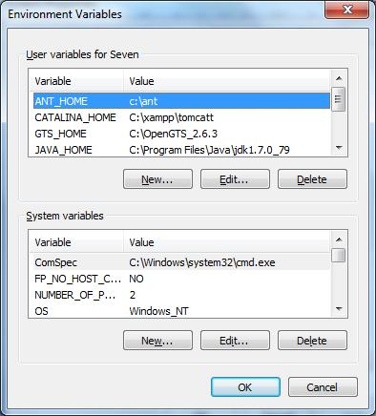

ADMIN CMD--

- Open command Prompt and go to D:\OpenGTS_2.6.2

- Type command ant all
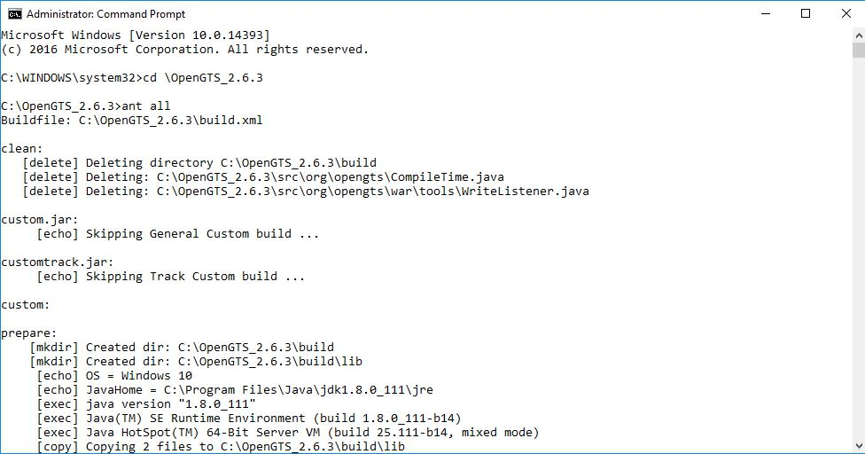

3) Type command ant track
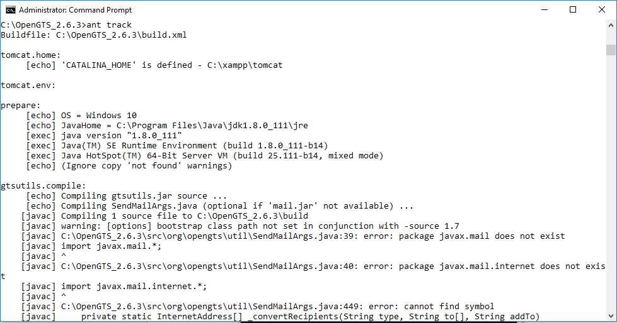

4) Type command ant track.deploy
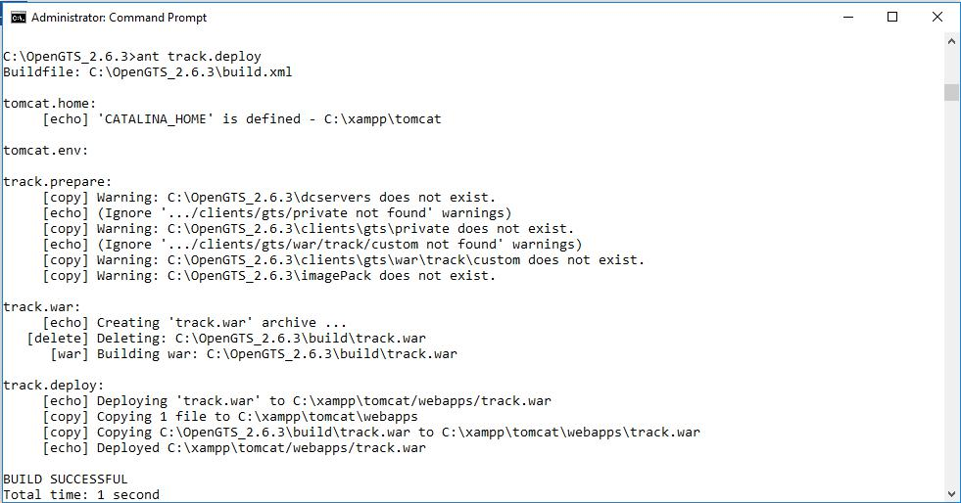

- (type cd bin)Type command initdb.bat –rootUser=root –rootPass=root

  - start Tomcat/MySQL.
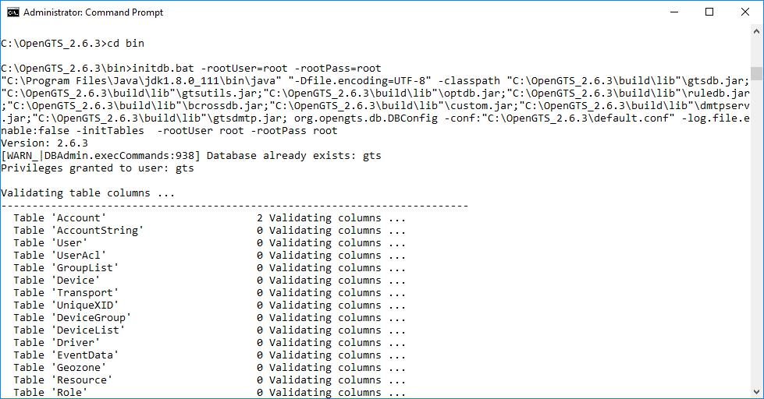

6) Type Command admin.bat Account –account:admin –pass:123456 –create
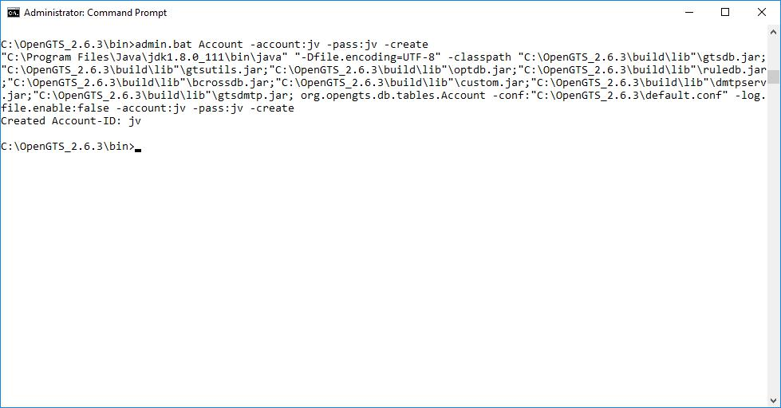

7) Type url 127.0.0.1:8080/track/Track and login with admin and 123456
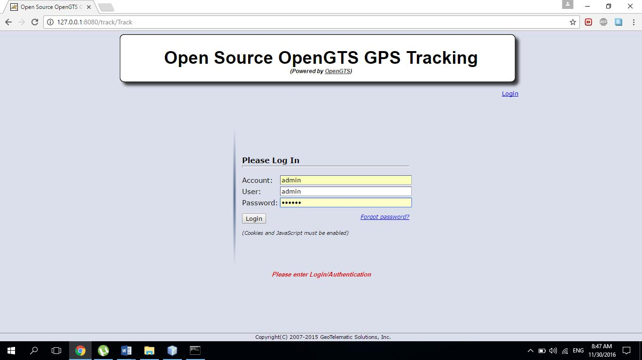

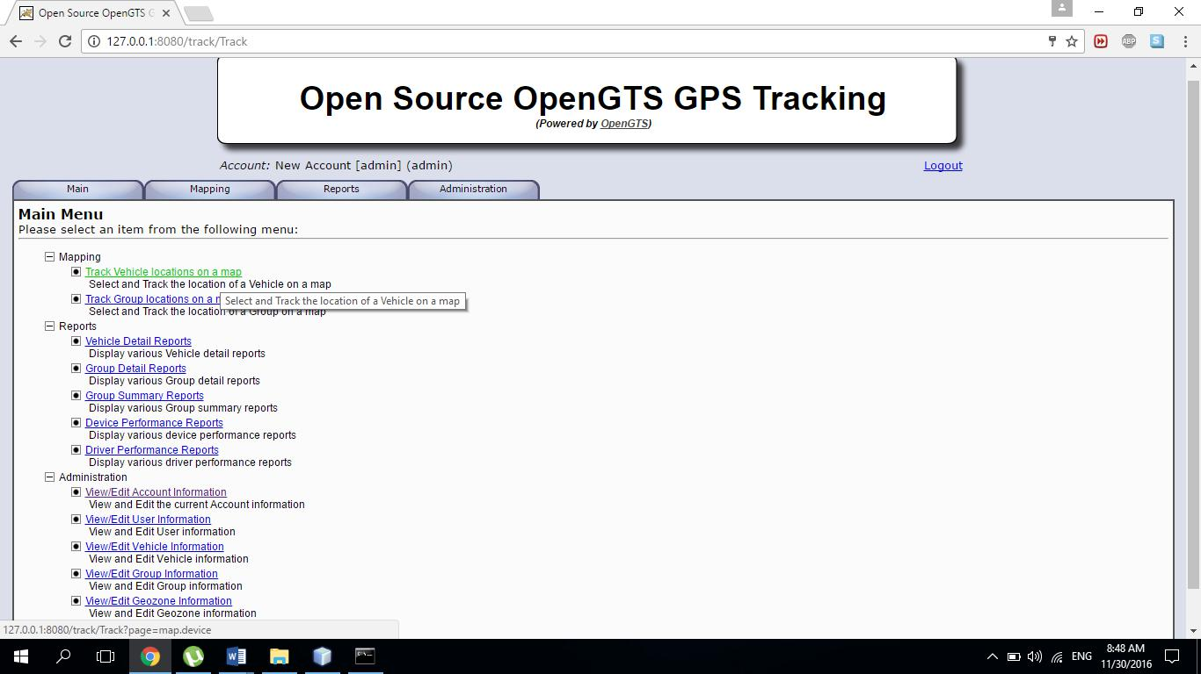
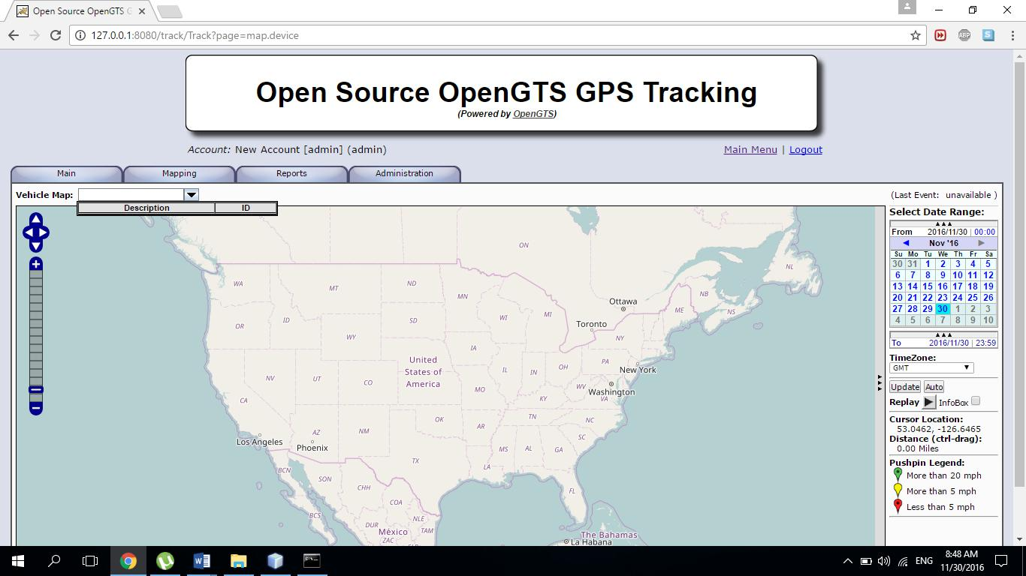

Practical No : 9 Date:

Aim : Develop application demonstrating Human Computer Interaction.

Source Code:

import java.awt.Color; import java.awt.Frame; import java.awt.Window;

import java.awt.event.WindowEvent; import java.awt.event.WindowListener;

public class CloseableSimpleWarning extends Frame implements WindowListener{

static private final int frame_height = 150; static private final int frame_width = 250;

public CloseableSimpleWarning() { setBackground(Color.gray); setForeground(Color.black); setTitle("HCI"); setSize(frame_width, frame_height); addWindowListener(this);
}

@Override

public void windowClosing (WindowEvent e) { System.out.println("Window is closing."); dispose();

}

public void windowClosed (WindowEvent e) { System.out.println("Window closed.");

}

@Override

public void windowIconified (WindowEvent e) { System.out.println("Window iconified.");

}

@Override

public void windowDeiconified (WindowEvent e) { System.out.println("Window deiconified.");

}

@Override

public void windowOpened (WindowEvent e) { System.out.println("Window opened.");

}

@Override

public void windowActivated (WindowEvent e) { System.out.println("Window activated.");

}

@Override

public void windowDeactivated (WindowEvent e) {

System.out.println("Window deactivated.");

}

public static void main(String [] args) { CloseableSimpleWarning f = new CloseableSimpleWarning(); f.setVisible(true);

}

}

OUTPUT:

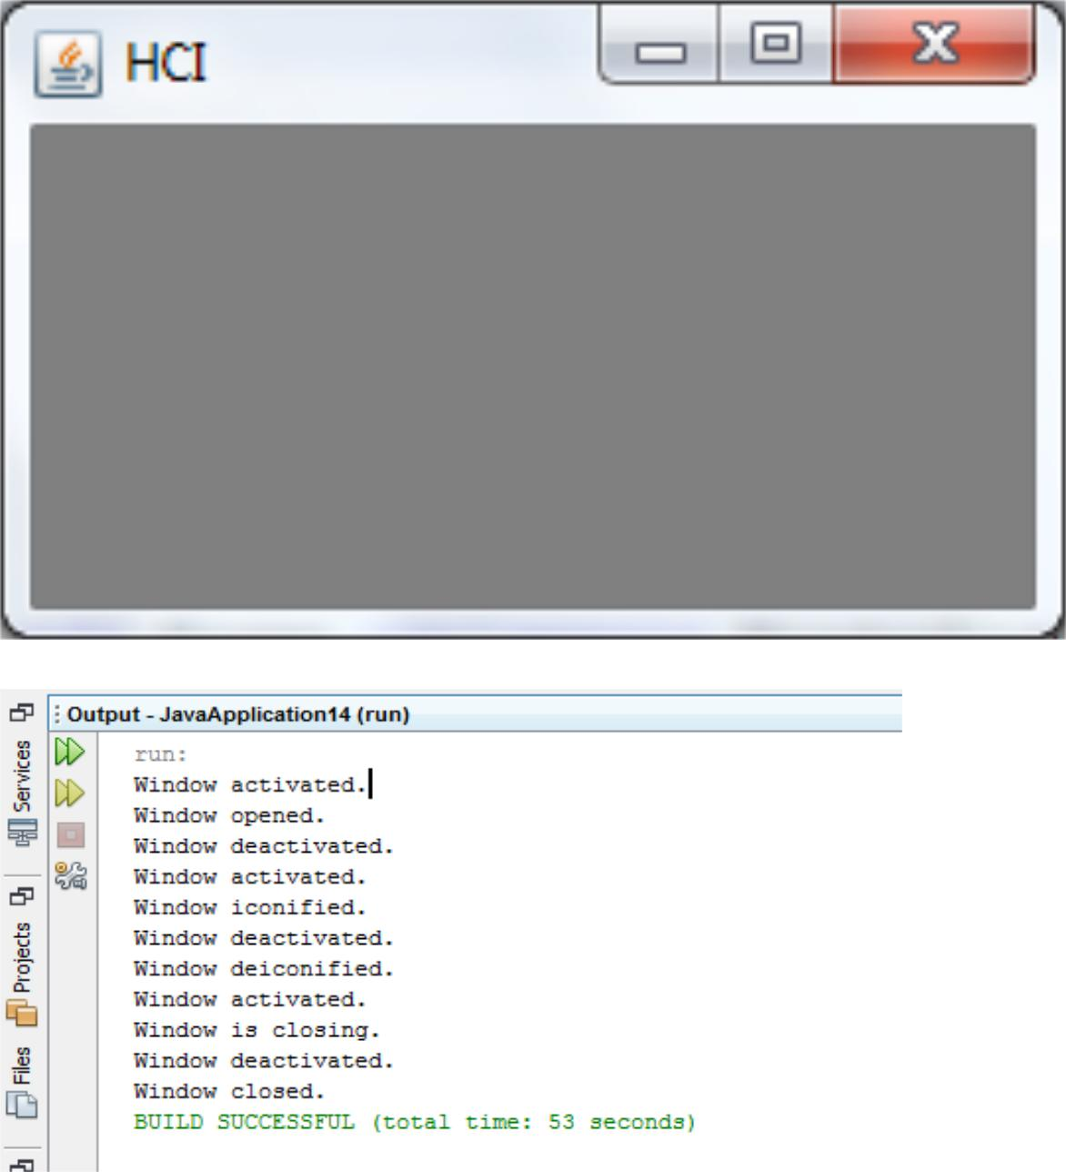

Practical No : 10 Date:

Aim : Write a Java Card applet.
Implementation :

Step 1 :-> Download Java Card Sdk from http://www.oracle.com/technetwork/java/embedded/javacard/downloads/javacard-sdk-2043229.html

if (plugin is there in NetBeans) Do nothing;

else

Install in Netbeans as plugin :-

Tools -> Plugin
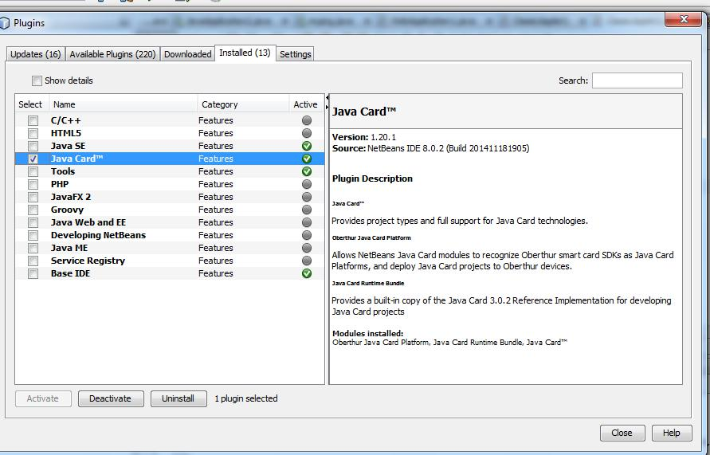

Step 2:->Create a Java Card Application
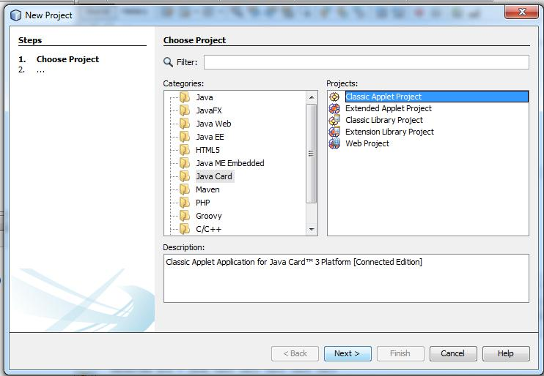

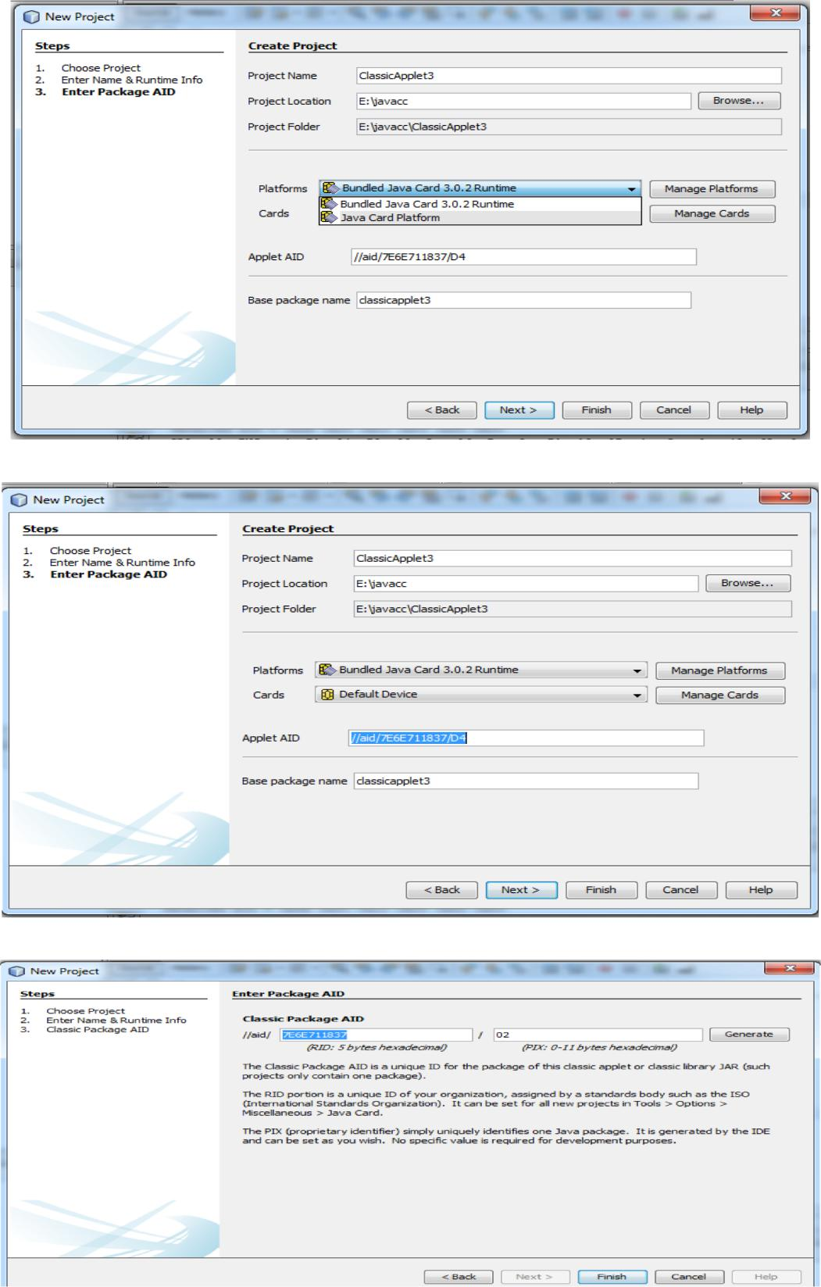

Source Code :

package classicapplet1; import javacard.framework.*;

public class ClassicApplet2 extends Applet { private byte[] received;

private static final short MAX_LENGTH = 256;

private static final byte[] helloFidesmo={(byte)'H',(byte)'e',(byte)'l',(byte)'l',(byte)'o',(byte)' ',(byte)'F',(byte)'i',(byte)'d',(byte)'e',(byte)'s',(byte)'m',(byte)'o',(byte)'!'};

public static void install(byte[] bArray, short bOffset, byte bLength) { new ClassicApplet2();

}

/**

* Only this class's install method should create the applet object. */

protected ClassicApplet2() {

received = new byte[MAX_LENGTH]; register();

}
public void process(APDU apdu) { //Insert your code here

byte buffer[] = apdu.getBuffer();

short length = (short) helloFidesmo.length; Util.arrayCopyNonAtomic(helloFidesmo, (short)0, buffer, (short)0, (short)length); apdu.setOutgoingAndSend((short)0, length);

}

}
OUTPUT:
